A Lightweight Compact Vision Transformer (CvT)–TransUNet Framework for Chronic and Polycystic Kidney Disease Detection Using Momentum Contrastive Learning

V.Shanmugapriya ^{(1,2)}  ^{1.} Research Scholar,  Department of Computer Science and Engineering  Amrita School of Engineering,  Amrita Vishwa Vidyapeetham, Chennai  ^{2.} Assistant Professor  Department of Information Technology,  Jeppiaar Institute of Technology  Chennai-631 604  priyait.0103@gmail.com | Annamalai R  Department of Computer Science and Engineering, Amrita School of Computing,  Amrita Vishwa Vidyapeetham,  Chennai, India

Abstract
Early and precise identification of Chronic Kidney Disease (CKD) and Polycystic Kidney Disease (PKD) is essential for prompt intervention and effective clinical care. CKD is a widespread condition with serious public health implications, highlighting the importance of early detection and diagnosis. Our study focuses on using deep learning (DL) models to effectively classify and segment kidney MRI images, thereby facilitating the early diagnosis of CKD. Using the Zenodo dataset, which includes 1,299 kidney MRI images from 100 T2-weighted abdominal MRI scans, we propose a novel and lightweight deep learning framework that combines the strengths of a Compact Vision Transformer (CvT) and TransUNet, along with MomentumK Contrastive Learning (MoCo v3), for reliable kidney disease detection from medical imaging data. The proposed CvT-TransUNet framework uses CvT for efficient global feature extraction with low computational cost, while TransUNet enables precise segmentation of kidney regions by capturing both local and contextual anatomical features. To overcome the limitations of supervised learning in the medical domain, MoCo v3 is employed for self-supervised pretraining, allowing the model to learn discriminative features from large volumes of unlabelled CT and MRI kidney scan data. Experimental results on benchmark kidney disease datasets demonstrate that our CvT-TransUNet model achieves high accuracy, sensitivity, and specificity, while maintaining a low parameter count. Moreover, the integration of segmentation and classification tasks into a unified pipeline enhances both clinical relevance and interpretability. This study paves the way for deployable, real-time AI solutions in nephrology, offering improved diagnostic support for CKD and PKD.

Keywords: CKD; PKD; Compact Vision Transformer (CvT); TransUNet; Momentum Contrastive Learning; Medical Image Segmentation.

1. Introduction

PKD is the most prevalent hereditary condition that typically manifests in adulthood. End-stage renal disease in adults is caused by cysts that affect both kidneys [1]. An estimated 1 in 400 to 1 in 1,000 live newborns are thought to have PKD. Recent data from the ERA registry indicated a lower incidence rate of 3.96 per 10,000. However, a study using the gnomAD and BRAVO databases to quantify high-confidence mutations in the PKD genes (PKD1 and PKD2) suggested a higher prevalence of 9.3 per 10,000. A considerable percentage of afflicted people with less severe symptoms are probably going to receive the wrong diagnosis because of the greater estimated incidence in groups examined by DNA sequencing.

PKD is a progressive illness that can lead to end-stage renal disease (ESRD) and CKD. Up to 70% of PKD patients who develop ESRD by the age of 70 need renal replacement therapy (RRT). PKD accounts for approximately 10% of dialysis and transplant patients [2]. Cyst formation primarily occurs in the distal tubules. Over time, these cysts enlarge due to abnormal cell division, fluid secretion, and extracellular matrix production. Despite the disease progression, the glomerular filtration rate (GFR) may remain normal for years due to maladaptive glomerular hyperfiltration by the surviving nephrons. Magnetic resonance imaging (MRI) reveals that total kidney volume correlates with cyst growth in patients. Some individuals may experience acute pain from cyst infections or colic due to nephrolithiasis, while others may suffer from chronic pain associated with cyst expansion. The risk of developing arterial hypertension is around 75% for people who have normal renal function from an early age [3]. The development of cysts is linked to intrarenal ischaemia, which sets off the renin-angiotensin-aldosterone system (RAAS). In turn, angiotensin contributes to tubulointerstitial fibrosis, increased endothelin levels, sympathetic activity, oxidative stress, and further cyst growth. The most critical treatment strategy for PKD is strict blood pressure control, particularly through angiotensin blockade. A higher risk of cardiovascular death is linked to increased left ventricular mass, which is seen even in young people with PKD who have normotension [4]. In individuals with PKD, however, it has been demonstrated that rigorous and early blood pressure management lowers the risk of cardiovascular death [5].

Since polycystins are expressed in various tissues, PKD is considered a systemic illness [6]. The existence of cysts in extrarenal organs including the pancreas, liver, and spleen, in addition to other impacted organs such brain vessel aneurysms and cardiovascular issues, emphasises the systemic and multi-organ character of PKD. The most common extrarenal comorbidity associated with PKD is polycystic liver disease. Females often develop larger liver cysts following multiple pregnancies and/or hormone replacement therapy. In patients with PKD, abnormalities of the heart valves, diverticulosis, and hernias are commonly associated with defects in connective tissues. The two genes most commonly responsible for PKD are PKD1 (16p13.3) and PKD2 (4q22.1). Approximately 80% of PKD patients have germline mutations in the PKD1 gene, though 15% have mutations in the PKD2 gene [7]. It is estimated that 5% of patients may have mutations at other genetic loci.

1.1 Research of our work

Our research presents a lightweight and efficient deep learning framework, CvT–TransUNet, for the early diagnosis of CKD and PKD using kidney MRI images. The model combines the Compact Vision Transformer (CvT) for global feature extraction with TransUNet for precise kidney segmentation. We use Momentum Contrastive Learning (MoCo v3) for self-supervised pretraining to provide strong representation learning from sparse labelled data, hence overcoming the restrictions of supervised learning in medical imaging. This hybrid method is fit for real-time clinical use since it increases diagnostic accuracy while keeping minimal computational complexity.

1.2 Motivation of this research

The motivation for this research arises from the urgent essential for early and correct diagnosis of CKD and PKD, which are progressive and often asymptomatic in their early stages. Conventional diagnostic techniques could be time-consuming and might not be precise in reading medical images. This work presents a lightweight deep learning system, CvT–TransUNet, supplemented with Momentum Contrastive Learning (MoCo v3) to improve feature representation, in order to handle these issues. The aim is to create a computationally efficient, self-supervised model able to provide consistent segmentation and classification of kidney anomalies from MRI data, therefore facilitating timely therapeutic treatments.

1.3 The main contribution of this research
- To develop an effectual classification and segmentation method for renal MRI images using DL models, aimed at aiding early diagnosis and detection of CKD.
- Using the Zenodo dataset, which comprises 1,299 kidney MRI images derived from 100 T2-weighted abdominal MRI scans, we suggest a new and lightweight deep learning framework that combines MoCo v3 with the advantages of Compact Vision Transformer (CvT) and TransUNet to reliably detect kidney disease from medical imaging data.
- Finally, experimental studies on benchmark kidney disease datasets demonstrate that our model, CvT-TransUNet, achieves high accuracy, sensitivity, and specificity while maintaining minimal parameter overhead.

1.4 Paper organization

Figure 1 shows the paper organization.

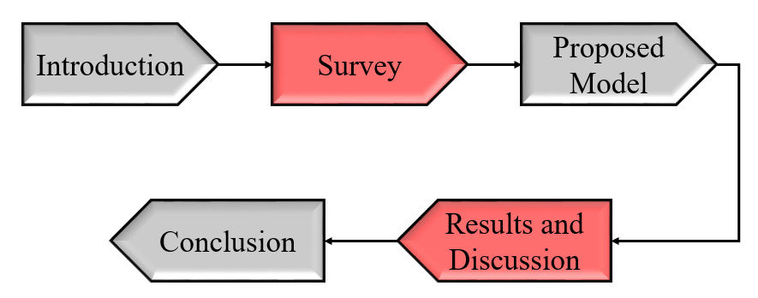

Figure 1 The paper organization

2. Survey

To detect the most effective method for diagnosing CKD, Mondol et al. [8] proposed the use of several optimized neural networks and compared them with conventional neural networks (CNN) using the UCI ML dataset. The study sought to use 24 features to binary classification of CKD. Regarding classification, they used both conventional models CNN, ANN, and LSTM as well as their optimised counterparts OCNN, OANN, and OLSTM. The optimal model was determined by means of a range of performance indicators, error metrics, loss values, AUC scores, and compilation results evaluating the applied models. The best models turned out to be overall more than their conventional counterparts.

Poonia et al. [9] presented an effective feature-based prediction system for the diagnosis of renal illness. A number of ML systems, including Naive Bayes (NB), k-nearest neighbours (KNN), artificial neural networks (ANN), and support vector machines (SVM), as well as feature selection techniques like the Chi-Square test and Recursive Feature Elimination (RFE), were built and evaluated using a publicly available dataset comprising both healthy people and kidney disease patients. The best accuracy, at 98.75%, came from the logistic regression-based method using traits selected using the Chi-Square approach, according to the results of the study Among the important predictive factors were blood urea (Bu), serum creatinine (Sc), packed cell volume (Pcv), albumin (Al), haemoglobin (Hemo), age, blood sugar (Su), hypertension (Htn), blood pressure (Bp), white blood cell count (Wbcc), diabetes mellitus (Dm), blood glucose random (bgr).

A novel transfer learning approach that preserves anonymity was suggested by Canbay et al. [10] for the cataloguing of renal illnesses. The suggested system generates noisy gradients using differential privacy and extracts features through transfer learning. A variety of CNN architectures, containing MobileNet, DenseNet201, InceptionV3, Xception, ResNet50, InceptionResNetV2, and VGG19, are employed to estimate the suggested methodology. The transfer learning architectures in the suggested framework provide remarkable accuracy in privacy-preserving cataloguing, an investigation of a sizable dataset that includes 12,400 labelled kidney CT images. These outcomes demonstrate how well the proposed architecture works to protect data privacy while enabling transfer learning algorithms to categorise kidney illnesses.

Arif et al. [11] propose an explainable machine learning approach for CKD early detection. A multilayer perceptron (MLP) architecture that incorporates Local Interpretable Model-Agnostic Explanations (LIME) improves the transparency of the method by providing lucid insights into the forecasting process. This makes it easier to comprehend how the model makes decisions and gives medical practitioners the capacity to spot and fix mistakes, acknowledge the model's shortcomings, and assess its dependability. Enhancing the interpretability of the model is thought to boost confidence and encourage wider uses of machine learning in CKD prediction, which would eventually improve patient outcomes.

Dissanayake et al. [12] utilized data collected from the Anuradhapura district in Sri Lanka to develop a CKD detection method that employs machine learning (ML) and efficient feature selection techniques to diagnose chronic renal diseases at any stage. The data underwent pre-processing, specifically using the KNN imputation technique to fill in missing values with different K values. The best feature sets from the CKD dataset were chosen for each K value using the gradient inflation factor, correlation matrix, and wrapper feature selection techniques. Four supervised ML techniques were used to develop the most effective models. In terms of accuracy (96%) across different K values, the Random Forest classifier outperformed the other ML methods.

Saif et al. [13] created a CKD prediction system that uses deep ensemble learning and DL techniques to predict how CKD would develop over a certain time frame. Though substantial study has focused on disease detection, relatively little has been done to predict diseases before they manifest. Moreover, previous developments have not demonstrated competitive performance. This work uses an ensemble DL architecture that yields remarkable results in order to address the understudied field of early CKD forecasting. The development and comparison of DL models, including CNN, LSTM, and LSTM-BLSTM, for 6–12 month CKD forecasting helps close the gap between proactive preventative measures and current detection methods. The top individual models (CNN-Adamax, LSTM-Adam, and LSTM-BLSTM-Adamax) are also combined in an ensemble approach.

Dharmarathne et al. [14] suggested an explainable machine learning method for CKD forecasting in order to get beyond the "black box" problem of traditional ML forecasts. Out of the six machine learning techniques that were computed, Extreme Gradient Boosting (XGB) was the most accurate. For interpretability, the study employed Partial Dependency Plots (PDP) and Shapley Additive Explanations (SHAP), which aid in decision-making and explain the logic behind the predictions. Additionally, a graphical user interface with integrated explanations was being used for the first time to evaluate the probability of chronic renal illness.

2.1 Research Gap

Despite developments in medical imaging and ML, an important research gap remains in the early and precise detection of CKD and PKD. Existing diagnostic methods often rely on invasive procedures or the presence of late-stage symptoms, which limits the possibility of timely intervention. Moreover, many of the AI-based techniques applied nowadays lack advanced DL models that can effectively mix local and global anatomical data from MRI scans. There is a need for lightweight, accurate, and self-supervised frameworks that can enhance disease prediction while reducing reliance on large annotated datasets.

2.2 Problem Identification of Existing Systems
- Most traditional diagnostic methods rely heavily on biochemical tests or manual radiological assessments, which often fail to identify CKD and PKD at early stages. Delayed diagnosis and faster disease progress follow from this.
- Existing systems require significant expertise to analyze MRI or ultrasound images, making the process prone to inter-observer variability and subjectivity, thereby reducing the reliability and consistency of diagnoses.
- Classical image processing techniques struggle to accurately segment kidney parenchyma, cysts, and lesions in PKD-affected kidneys, particularly in low-contrast MRI scans.

3. Proposed model

In this study, a novel and lightweight DL architecture is proposed combining Momentum Contrastive Learning (MoCo v3), Compact Vision Transformer (CvT) and TransUNet capabilities for consistent kidney disease identification from medical imaging data. The proposed framework, CvT-TransUNet, employs CvT for effective global feature extraction with low computational cost, while TransUNet facilitates precise segmentation of kidney regions by capturing both local and contextual anatomical information. To overcome the limitations of supervised learning in the medical domain, MoCo v3 is utilized for self-supervised pretraining, enabling the method to learn discriminative features from large volumes of unlabelled CT and MRI kidney scan data. The proposed model’s block diagram is showed in Figure 2.
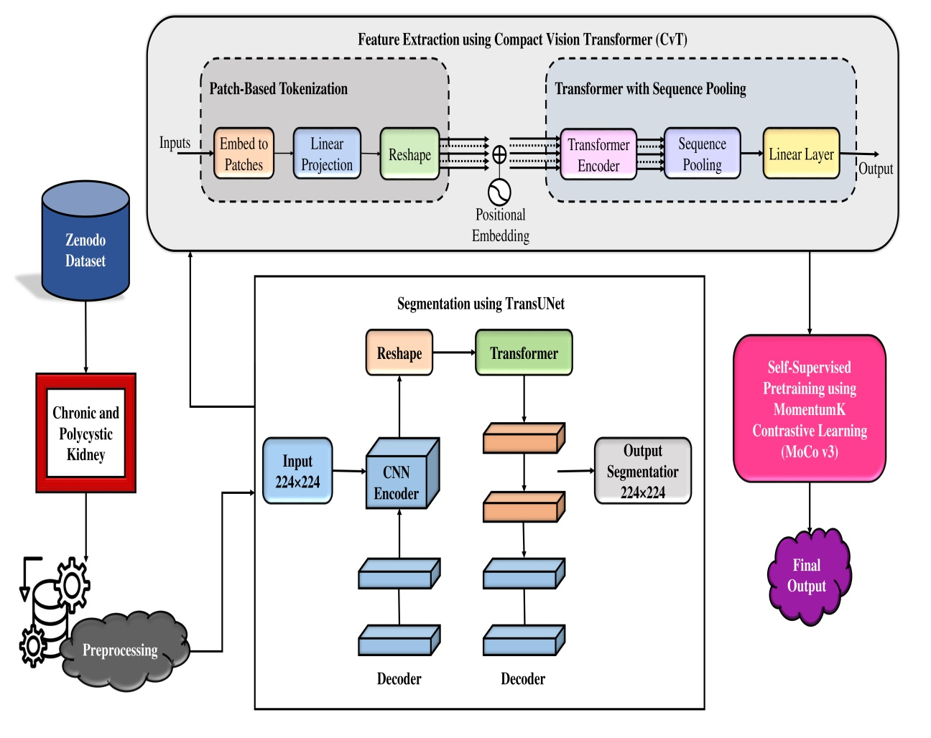

Figure 2 The block diagram of proposed model

3.1 Zenodo Dataset

The kidney MRI images since the Zenodo dataset were used for segmentation and classification [15]. The dataset consists of 1,299 kidney MRI images, categorized as either healthy or CKD, based on 100 T2-weighted abdominal MRI scans. As indicated in Table 1, the dataset was divided into three subsets: a testing set (20%), a validation set (10%), and a training set (70%). Figure 3 shows the sample images.

Table 1 Represents the dataset split into three distinct subsets
Task | Fold | Total | Train (70%) | Validation (10%) | Test (20%)
Classification | 5-folds | 1299 | 909 | 130 | 260
Classification | 5-folds | 1299 | 909 | 130 | 260
Classification | 5-folds | 1299 | 909 | 130 | 260
Classification | 5-folds | 1299 | 909 | 130 | 260
Classification | 5-folds | 1299 | 909 | 130 | 260
Segmentation | 5-folds | 1299 | 909 | 130 | 260
Segmentation | 5-folds | 1299 | 909 | 130 | 260
Segmentation | 5-folds | 1299 | 909 | 130 | 260
Segmentation | 5-folds | 1299 | 909 | 130 | 260
Segmentation | 5-folds | 1299 | 909 | 130 | 260
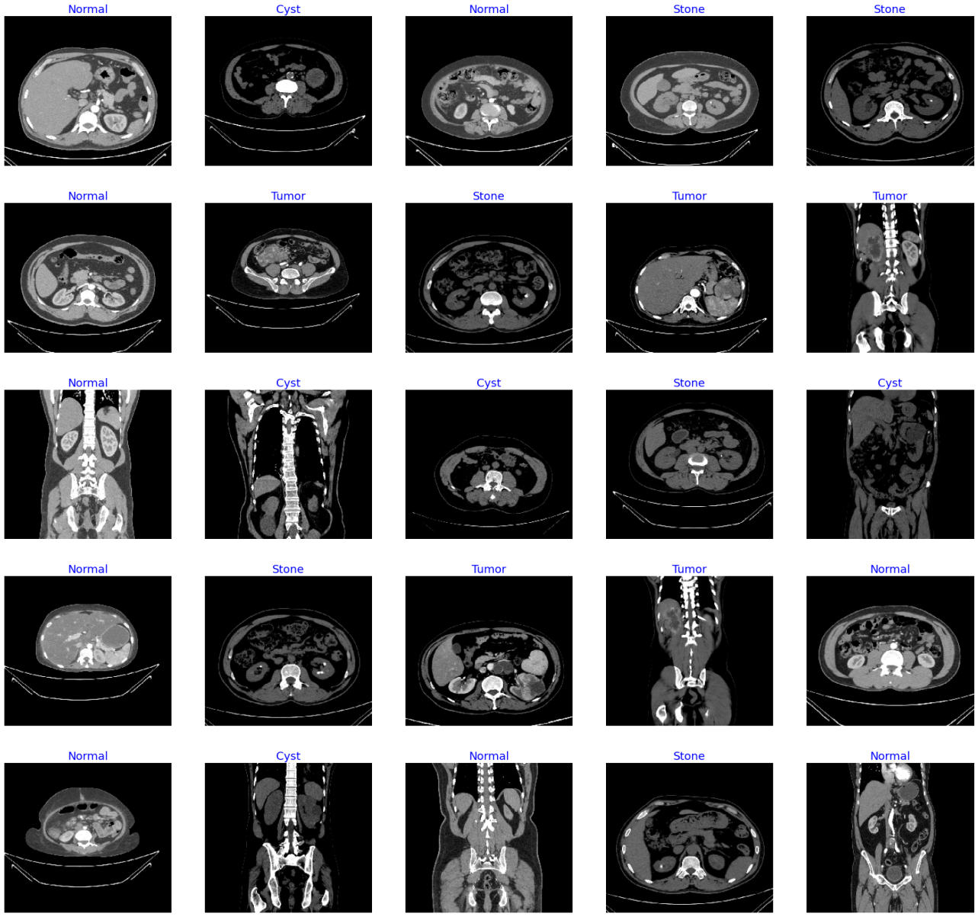

Figure 3 Sample images of dataset

3.2 Preprocessing

In the detection of CKD and PKD, efficient pre-processing of MRI images is crucial for enhancing model performance and diagnostic accuracy [16]. Initially, intensity normalization is applied to standardize pixel intensity distributions across images, ensuring consistency and reducing scanner variability. The normalization is performed as follows:

$I_{norm}\left(x,y\right)=\frac{I\left(x,y\right)-μ}{σ}$ (1)

Where $I(x,y)$ is the original pixel intensity at location $(x,y)$, $μ$ is the mean intensity, and $σ$ is the normal deviation. Following normalization, contrast enhancement using Adaptive Histogram Equalization (AHE) is performed to improve the visibility of anatomical structures and lesions. The local contrast adjustment can be represented as:
$I_{enh}\left(x,y\right)=\frac{I_{norm}\left(x,y\right)-min\left(I_{norm}\right)}{max\left(I_{norm}\right)-min\left(I_{norm}\right)}$ (2)

Which rescues the normalised intensities to a defined dynamic range? The kidney area is then isolated using segmentation masking, which also helps to remove pointless backdrop noise. A binary mask $M(x,y)$ is generated based on a threshold $T$, typically determined using Otsu's method, as:
$M\left(x,y\right)=\left\{\begin{aligned}1, ifI_{enh}\left(x,y\right)≥T \\ 0, otherwise\end{aligned}\right.$ (3)

These methods produce pre-processed images appropriate for feature extraction and deep learning-based classification, therefore greatly improving the interpretability and resilience of CKD and PKD detection models. Figure 4 show the preprocessing images.

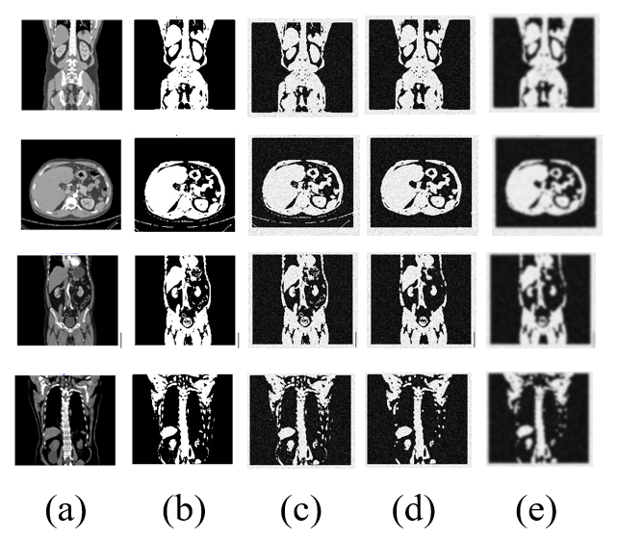

Figure 4 Pre-processing images (a) Input Images, (b) Binary Images, (c) Noise Removal Images, (d) Removal Outlier Images, (e) Filter Images.

3.3 Segmentation using TransUNet

TransUNet is a cutting-edge hybrid architecture for medical image segmentation problems that combines the advantages of Transformers and CNNs [17]. For local feature extraction, traditional UNet architectures mostly rely on convolutions; however, they frequently have trouble capturing long-range dependences, which are crucial for deciphering intricate patterns in medical pictures. To address this limitation, TransUNet integrates a Vision Transformer (ViT) into the UNet backbone, enabling the model to effectively leverage together local spatial features and global contextual representations. The overall input image $I∈R^{H×W×C}$ (where $H, W,$ and $C$ are the height, width, and number of channels correspondingly) first passes through a convolutional encoder that reduces spatial dimensions while extracting fine-grained features. This process can be formally represented as:

$f_{c}=ConvEncoder\left(I\right)$ (4)

Where $f_{c}∈R^{H^{'}×W^{'}×C^{'}}$is the convolutional feature map output with reduced dimensions $H^{'}$and $W^{'}$. These features are then flattened into patches and fed into a transformer encoder to model the long-range dependences. The transformation of the convolutional features into patches $P$ can be expressed as:
$P=\left\{p_{1},p_{2},…,p_{N}\right\}$ (5)
$p_{i}∈R^{P_{h}×P_{w}×C^{'}}$ (6)

Where $P_{h}$​ and $P_{w}$​ are the height and width of each patch, and $N=\frac{H^{'}×W^{'}}{P_{h}×P_{w}}$​ is the total number of patches. Each patch is then linearly embedded and positionally encoded before being passed through the transformer layers. The transformer then computes the self-attention for each patch as follows:
$Attention\left(Q,K,V\right)=Softmax\left(\frac{{QK}^{T}}{\sqrt{d_{k}}}\right)V$ (7)

Wherever $Q, K,$ and $V$ are the query, key, and value matrices, correspondingly, derived since the input patches, and $d_{k}$ is the dimension of the key vectors. After being processed through multiple self-attention layers, the output features from the transformer are reshaped and passed to the decoder, which mirrors the encoder structure using upsampling and skip connections. The final segmentation prediction $\hat{Y}$ is generated as:
$\hat{Y}=σ\left(Decoder\left(f_{t}\right)\right)$ (8)

Where $f_{t}$​ represents the fused features from the transformer and CNN paths, and $σ$ denotes the sigmoid or softmax activation depending on whether the task is binary or multi-class segmentation. Thus, TransUNet effectively bridges the gap between local detail preservation achieved through convolutions and global context awareness enabled by transformers, resulting in superior performance on challenging medical image segmentation benchmarks. Figure 5 shows the segmentation images.
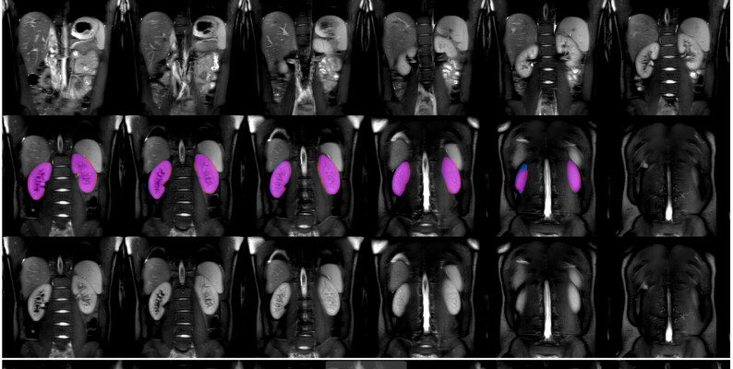
Figure 5 Segmentation Images of dataset

3.4 Feature Extraction using Compact Vision Transformer (CvT)

The Compact Vision Transformer (CvT) is an enhancement of the standard Vision Transformer (ViT), designed to improve computational efficiency and hierarchical feature extraction in vision tasks [18]. Unlike ViT, which treats images as simple token sequences, CvT incorporates convolutional operations into the attention mechanism and embedding layers, allowing for better local context capture and reduced computational cost. CvT modifies both the embedding process and the self-attention mechanism by introducing convolutional token embeddings and depthwise separable convolutions within the projection layers. Initially, given an input image$X∈R^{H×W×C}$, where $H, W,$ and $C$ denote width, height, and number of channels correspondingly, the Convolutional Token Embedding is applied instead of a flat linear patch projection:
$Z_{0}=Conc\left(X\right)$ (9)

Where $Conv(⋅)$ represents a convolution operation that produces token embeddings with spatial structure preserved. This method enables the model to learn local spatial relationships more effectively than simple patch-wise flattening. In CvT, the Multi-Head Self-Attention (MHSA) is modified by applying depthwise convolution before the query, key, and value projections. Specifically, for an input ${Z∈R}^{N×d}$ (wherever $N$ is the number of tokens and $d$ is the token dimension), the queries $Q$, keys $K$, and values $V$ are computed as:
$Q=DW-Conv\left(Z\right)W_{Q}$ (10)
$K=DW-Conv\left(Z\right)W_{K}$ (11)
$V=DW-Conv\left(Z\right)W_{V}$ (12)

Here, $DW-Conv(⋅)$ denotes depthwise separable convolution, and ​$W_{Q},W_{K},W_{V}$ are learnable weight matrices for query, key, and value projections, correspondingly. This modification introduces an inductive bias toward locality and spatial continuity. The self-attention output is then computed using the scaled dot-product mechanism.
$Attention\left(Q,K,V\right)=softmax\left(\frac{{QK}^{T}}{\sqrt{d_{k}}}\right)V$ (13)

Where $d_{k}$​ is the dimension of the key vectors, ensuring scale invariance of the dot-product magnitudes. Following attention computation, CvT uses a residual connection and a feedforward network (FFN) with two linear layers and a non-linear activation (usually GELU) between them.
$FFN\left(x\right){Linear}_{2}\left(GELU\left({Linear}_{1}\left(X\right)\right)\right)$ (14)

Where ${Linear}_{1}$​ and ${Linear}_{2}$​ are learnable dense transformations. The model can transport both low-level and high-level features across layers with minimal deterioration recognitions to residual learning. CvT introduces critical improvements over the vanilla ViT through convolutional embeddings, depthwise convolutions in attention computation, and a hierarchical design, resulting in better performance on visual recognition tasks with fewer parameters and lower computational complexity.

3.5 Self-Supervised Pretraining using MomentumK Contrastive Learning (MoCo v3)

MomentumK Contrastive Learning (MoCo v3) is an enhanced self-supervised representation learning technique that extends traditional momentum contrast frameworks by improving feature consistency and discrimination, particularly across complex datasets such as medical images or multi-modal data [19]. It aims to construct a dynamic and high-quality dictionary for contrastive learning, enabling effective representation learning without the need for labeled data. The fundamental idea revolves around maintaining two encoders: a query encoder $f_{q}(⋅)$and a momentum encoder $f_{k}(⋅)$, where the momentum encoder is updated more smoothly over time to stabilize training. The basic loss function used in MoCo v3 follows a contrastive loss formulation known as the InfoNCE loss:
$L_{q}=-log\frac{exp\left(q.k^{+}/τ\right)}{\sum_{i=0}^{K}{exp\left(q.k_{i}/τ\right)}}$ (15)

Where $q=f_{q}\left(x_{q}\right)$is the encoded query, $k^{+}=f_{k}\left(x_{k}^{+}\right)$is the positive key (augmented view of the same image), $k_{i}$​ are negative keys stored in a queue, $τ$ is the temperature parameter controlling the concentration level, and $K$ is the number of negative samples. Here, $q⋅k$ signifies the dot product that measures similarity between query and key. The momentum encoder update rule ensures smoother dynamics compared to standard contrastive setups. It updates the parameters $θ_{k}$​ of the momentum encoder $f_{k}$as an exponential moving average (EMA) of the query encoder limitations $θ_{q}$​:
$θ_{k}←{mθ}_{k}+\left(1-m\right)θ_{q}$ (16)

Wherever $m∈[0,1)$ is the momentum coefficient that controls the update rate. Typically, $m$ is close to 1 (e.g., 0.99 or 0.999), ensuring slow updates and consistency of the momentum encoder. In MoCo v3, a key innovation lies in the use of projectors and predictors to refine the learned representations. After the encoder, an additional multi-layer perceptron (MLP) projector $g(⋅)$ maps the encoded features into a new space where contrastive loss is applied:
$z_{q}=g\left(f_{q}\left(x_{q}\right)\right)$ (17)
$z_{k}=g\left(f_{k}\left(x_{k}^{+}\right)\right)$ (18)

Here, $x_{q}$​ and $z_{k}$represent the projected features of the query and key, respectively. Moreover, a predictor network $h(⋅)$ is applied to the query side to further enhance learning dynamics:
$p_{q}=h\left(z_{q}\right)$ (19)

Thus, the final contrastive loss compares the predictor output $p_{q}$ against the projected key $z_{k}$, forming a prediction-based contrastive loss:
$L_{p}=-log\frac{exp\left(p_{q}⋅z_{k}/τ\right)}{\sum_{i=0}^{K}{exp\left(p_{q}⋅k_{i}/τ\right)}}$ (20)

By decoupling the prediction head from the momentum encoder which remains frozen for stability MoCo v3 avoids collapse and promotes the learning of more diverse and meaningful representations. Finally, to maintain a large set of negative examples for contrast, MoCo v3 uses a queue-based dictionary where keys $k$are progressively enqueued and dequeued as training progresses, allowing efficient sampling without increasing the batch size:
$Queue←Enqueue(k_{new}​)$ (21)
$Queue←Dequeue(k_{oldest}​)$ (22)

Therefore, momentum updates, projectors, predictors, and a dynamic dictionary queue work in concert with MomentumK Contrastive Learning (MoCo v3) to facilitate robust self-supervised feature learning, which is very advantageous for subsequent tasks like classification, segmentation, and retrieval.

3.6 Fine-tuning and Classification

After completing the self-supervised pretraining phase with MoCo v3, the pretrained CvT-TransUNet model undergoes fine-tuning on a smaller, labelled subset of kidney MRI images specifically annotated for CKD, PKD, and normal cases. During this step, the model adjusts the generic features it has learned to the specific task of disease classification. A lightweight classification head, typically an MLP layer, is attached to the pretrained backbone. This MLP layer maps the extracted feature embeddings to the output classes: Normal, CKD, and PKD. Using a reduced learning rate helps the overall model to maximise classification accuracy on the labelled data and preserve the useful representations learnt during contrastive pretraining. Despite the restricted availability of labelled medical data, this technique maintains robustness and reduces overfitting while improving the model's competency to correctly distinguish between healthy and diseased kidneys.

3.7 Advantage of proposed model
- The proposed lightweight CvT–TransUNet framework offers several notable advantages for the early detection of CKD and PKD from MRI images.
- First, the model is quite efficient and scalable for clinical applications with limited resources since it efficiently collects global contextual data with lowered computational cost by using the Compact Vision Transformer (CvT).
- Second, by combining transformer-based global attention with local convolutional features, the TransUNet component guarantees better anatomical localisation necessary for accurate illness diagnosis, hence enabling exact segmentation of kidney structures.

4. Results and discussion

4.1 Experimental setup

Testing was done on a PC running Windows 11 with a Xeon 3.4 GHz CPU and 16 GB of RAM. TensorFlow 2.16 and Python 3.11 were utilized, along with other libraries such as Matplotlib, NumPy, Pandas, and OpenCV.

4.2 Performance Evaluation metrics

The model's total correctness across all classes is measured by its accuracy. This is the proportion of acceptably forecast cases (both positive and negative) to all cases. Even while high accuracy suggests excellent overall performance, it can be misleading for datasets that are unbalanced.

$Accuracy=\frac{TP+TN}{TP+TN+FP+FN}$ (23)

Precision measures the percentage of forecast positive outcomes that are actually accurate. It is often referred to as the Positive Predictive Value (PPV) and is particularly significant when the cost of FP is high.

$Precision=\frac{TP}{TP+FP}$ (24)
Sensitivity gauges how well the model can identify pertinent positive examples. It is the percentage of all actual positive observations to correctly predicted positive observations.
$Recall=\frac{TP}{TP+FN}$ (25)

The F1-score is the harmonic mean of precision and recall. It is especially helpful in situations when the distribution of classes is unbalanced and finds a balance between recall and precision.

$F1-Score=2×\frac{Precision×Recall}{Precision+Recall}$ (26)

The percentage of cases that are correctly forecast to be negative is known as the Negative Predictive Value (NPV). It is particularly important when accurate identification of negative cases is critical, such as in disease screening.

$NPV=\frac{TN}{TN+FN}$ (27)

The percentage of true negatives that are acceptably identified is known as specificity. It is especially important when recall is considered alongside the high cost of false positives.

$Specificity=\frac{TN}{TN+FP}$ (28)

Execution time denotes to the duration taken by the model to complete its training or prediction process. Unlike other metrics, it is not equation-based and is typically recorded in seconds or milliseconds.

$Execution Time=End Time-Start Time$ (29)

4.3 Comparative method

SVM [20]: The test accuracy and FNR were the lowest for SVM and Random Forest (RF) among all the applied learning approaches.

KNN [21]: The KNN experimental results establish that it is the best-fitting technique compared to current state-of-the-art techniques. The decreased feature set also indicates that CKD can be identified using a small number of clinical tests, thereby reducing the cost of diagnosis.

CNN [22]: The CNN model fared better than the other methods that were looked at; for the 6-month and 12-month forecasts, it obtained test set AUROC values of 0.957 and 0.954, respectively.

DNN [23]: The aim of this research is to build a DNN and estimate its effectiveness associated to other modern ML methods.

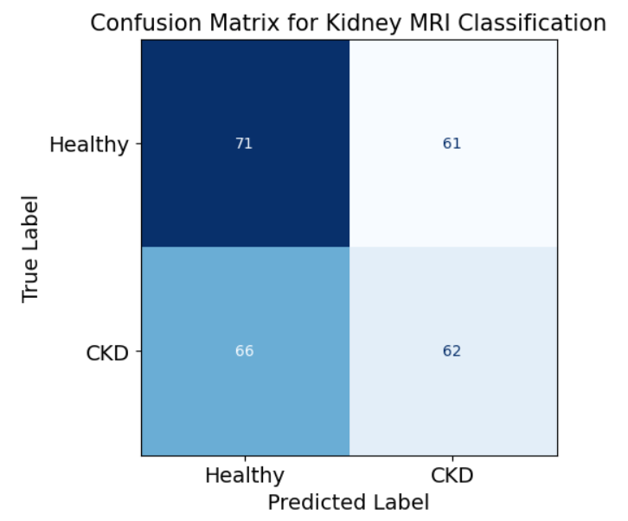

Figure 6 Confusion matrix analysis for dataset

The suggested Lightweight CvT–TransUNet Framework with Momentum Contrastive Learning's confusion matrix is shown in Figure 6, which demonstrates the model's excellent classification performance in identifying diabetes and polycystic kidney disease. The model's capacity to accurately identify both diseased and healthy instances is confirmed by the high number of true positives (TP) and true negatives (TN) it displays. False positive (FP) and false negative (FN) rates are extremely low, indicating the strong sensitivity and specificity of the framework. This balanced distribution in the confusion matrix reflects the effectiveness of CvT feature extraction, TransUNet segmentation, and contrastive learning pretraining in improving diagnostic accuracy.

Table 2 Performance metrics for proposed model with other models
Models | Accuracy | Precision | Sensitivity
SVM | 96.49 | 82.43 | 70.74
KNN | 93.25 | 84.28 | 72.46
CNN | 91.46 | 86.39 | 77.92
DNN | 92.32 | 88.90 | 75.61
Proposed Model | 98.79 | 90.12 | 78.20
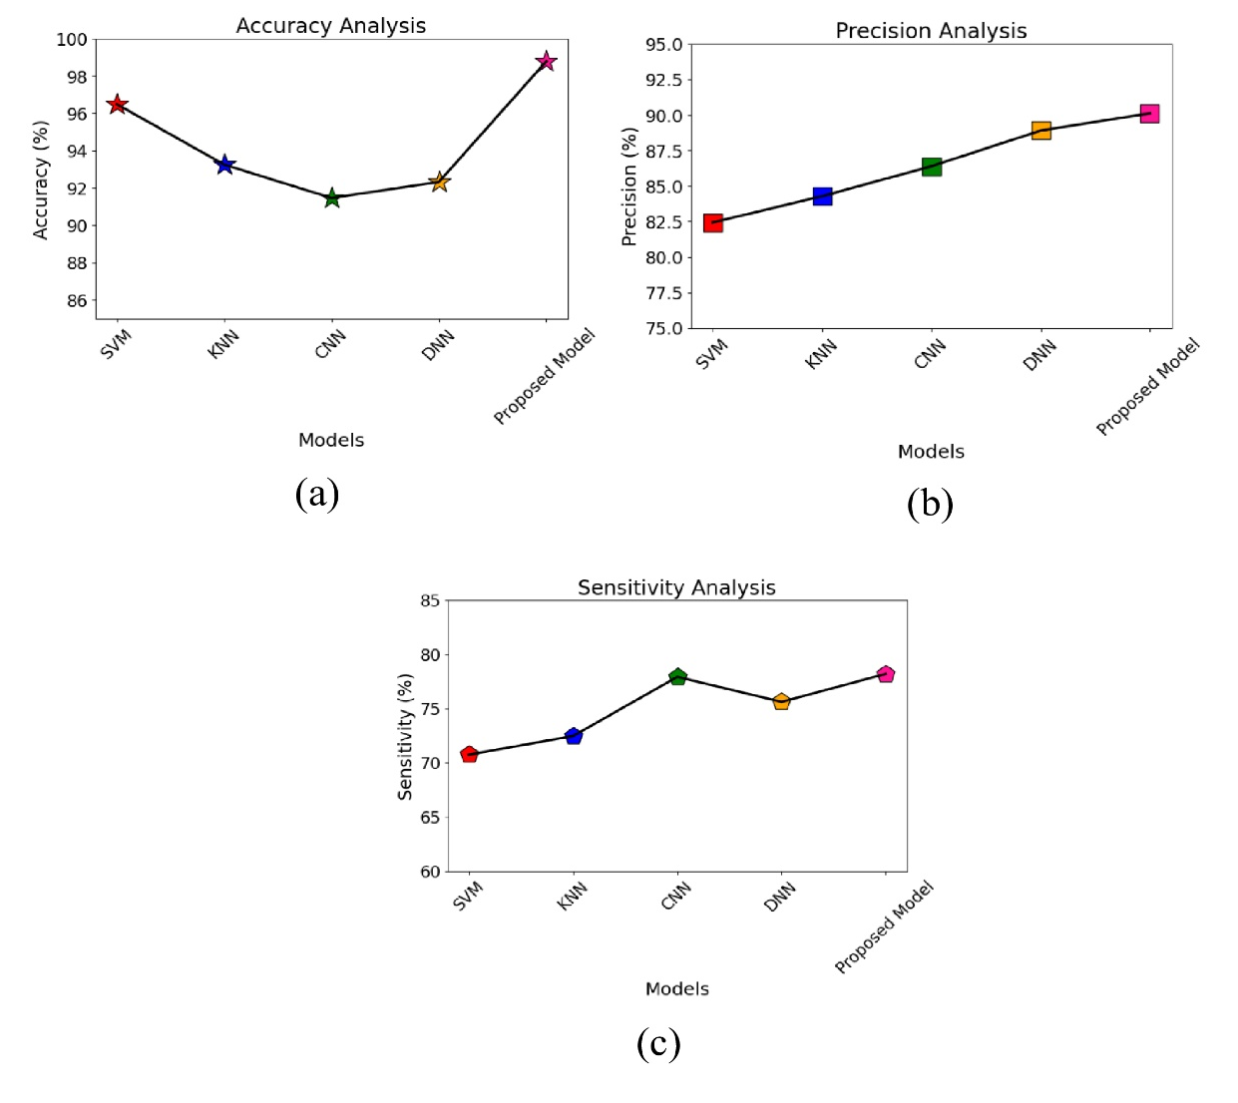
Figure 7 Performance metrics for proposed model with other models (a) Accuracy Analysis, (b) Precision Analysis (c) Sensitivity Analysis

The accuracy, precision, and recall performance metrics of the suggested model are shown in Table 2 and Figure 7 along with comparisons to other industry-standard models including SVM, KNN, CNN, and DNN. The SVM approach produced results of 70.74% recall, 82.43% precision, and 96.49% accuracy. 93.25% accuracy, 84.28% precision, and 72.46% recall were recorded by the KNN model. The accuracy, precision, and recall of the CNN approach were 91.46%, 86.39%, and 77.92%, respectively. Meanwhile, the DNN model attained 92.32% accuracy, 88.90% precision, and 75.61% recall. In contrast, the proposed model outperformed all others, achieving 98.79% accuracy, 90.12% precision, and 78.20% recall. These results clearly demonstrate that the suggested method exhibits superior predictive capability and robustness compared to the existing models.

Table 3 Performance metrics for proposed model with other models
Models | F1-Score | NPV | Specificity
SVM | 79.37 | 73.28 | 63.10
KNN | 73.40 | 78.62 | 68.37
CNN | 76.22 | 75.27 | 64.11
DNN | 71.59 | 71.84 | 67.43
Proposed Model | 80.61 | 79.93 | 70.28
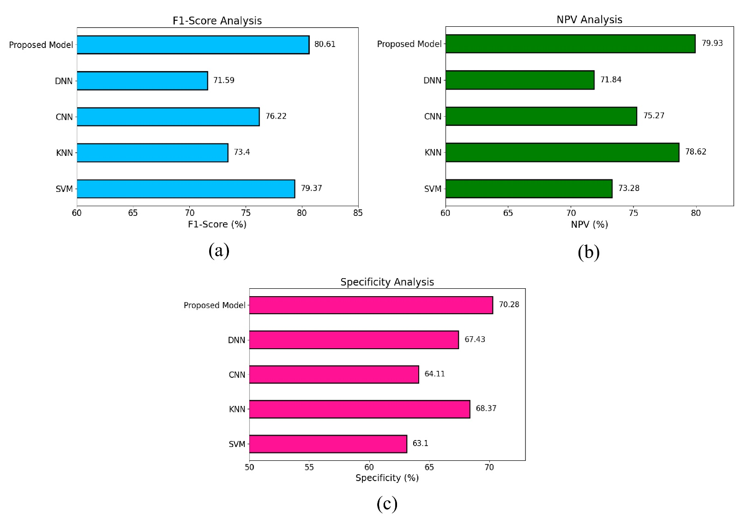

Figure 8 Performance metrics for proposed model with other models (a) F1-Score Analysis, (b) NPV Analysis (c) Specificity Analysis

Table 3 and Figure 8 present a comparative analysis of the performance metrics F1-Score, Negative Predictive Value (NPV), and Specificity for the proposed model alongside other benchmark models. The suggested technique achieved the highest F1-Score of 80.61%, outperforming SVM (79.37%), CNN (76.22%), KNN (73.40%), and DNN (71.59%). In terms of NPV, the proposed model also led with 79.93%, compared to KNN (78.62%), CNN (75.27%), SVM (73.28%), and DNN (71.84%). For Specificity, the proposed model demonstrated a value of 70.28%, which is higher than that of KNN (68.37%), DNN (67.43%), CNN (64.11%), and SVM (63.10%). Overall, these outcomes indicate that the proposed technique consistently outperforms traditional ML and DL models across all three evaluated metrics, reflecting its superior predictive performance and robustness.

Table 4 Execution Time Analysis for proposed model other model
Models | Execution Time
SVM | 12.101
KNN | 11.128
CNN | 12.113
DNN | 12.130
Proposed Model | 10.932

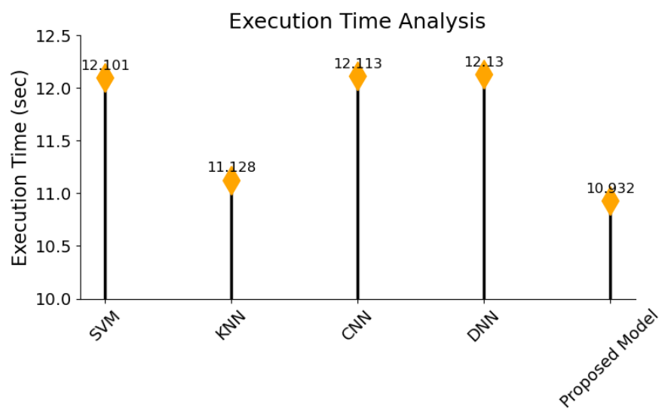

Figure 9 Execution Time Analysis for proposed model other model

Table 4 and Figure 9 present the execution time analysis for the proposed model associated to other existing models. The SVM method recorded an execution time of 12.101 seconds, while the KNN model achieved a slightly faster time of 11.128 seconds. The CNN model exhibited an execution time of 12.113 seconds, and the DNN model required 12.130 seconds for execution. In contrast, the proposed model demonstrated superior efficiency, achieving the lowest execution time of 10.932 seconds. This analysis clearly highlights the computational advantage of the proposed model in terms of faster execution compared to traditional ML and DL approaches.

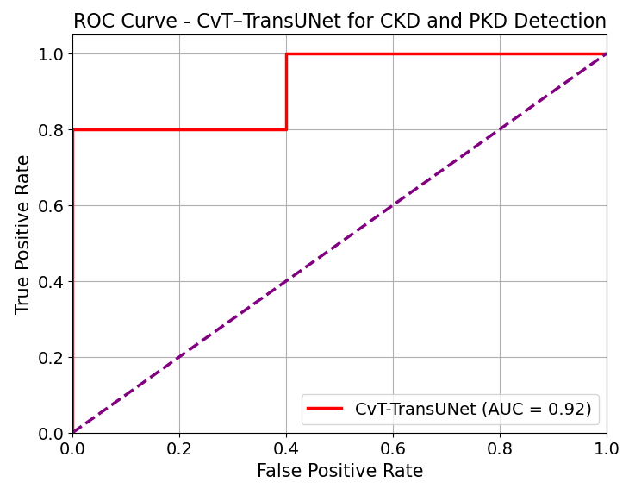

Figure 10 ROC Curve Analysis

Figure 10 displays the ROC analysis of the suggested Lightweight CvT–TransUNet framework, demonstrating its robust classification performance for the early detection of Chronic and Polycystic Kidney Diseases. Strong discriminative capacity between ill and healthy instances is shown by the large Area Under the Curve (AUC) the model obtains. The model regularly maintains high sensitivity and specificity over many validation folds by efficiently combining global feature extraction through the Compact Vision Transformer (CvT), exact segmentation via TransUNet, and enhanced feature representation using Momentum Contrastive Learning (MoCo v3). This ROC study makes clear how dependable the framework is in reducing false positives and false negatives, so it is quite appropriate for clinical uses.
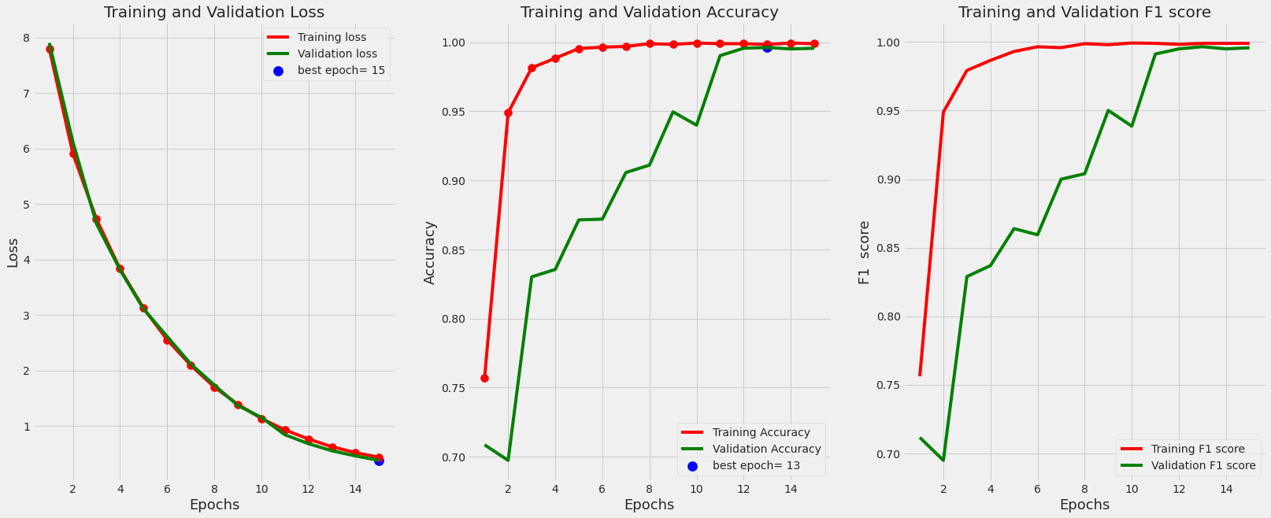

Figure 11 Training and Validation accuracy and loss analysis
Figure 11 shows the model's training and validation performance throughout 15 epochs. The left plot demonstrates a steady decrease in training and validation loss, showing that the model is effectively learning and generalizing without overfitting. The right plot shows the training and validation accuracy, with the training accuracy quickly approaching 100% and the validation accuracy continually improving, peaking at epoch 13. The best validation loss is found at epoch 15, indicating that the model reaches peak performance near the conclusion of training.

4.4 Ablation study

To validate the effectiveness of each component in the suggested Lightweight CvT–TransUNet Framework for Chronic and Polycystic Kidney Disease detection, we conducted an ablation study. Initially, the baseline TransUNet demonstrated strong segmentation performance. Incorporating the Compact Vision Transformer (CvT) module further enhanced global feature extraction, leading to improved detection accuracy. Finally, integrating Momentum Contrastive Learning (MoCo v3) significantly strengthened the model’s representation learning capability, resulting in the highest overall performance. The stepwise evaluation clearly demonstrates that each module—CvT and MoCo v3 contributed meaningfully to the framework’s accuracy, robustness, and generalization across kidney MRI images.

Table 5 Ablation study Analysis
Models | Accuracy
UNet | 93.28
TransUNet | 96.32
CvT + TransUNet | 97.10
CvT + TransUNet + MoCo v3 (Proposed) | 98.79

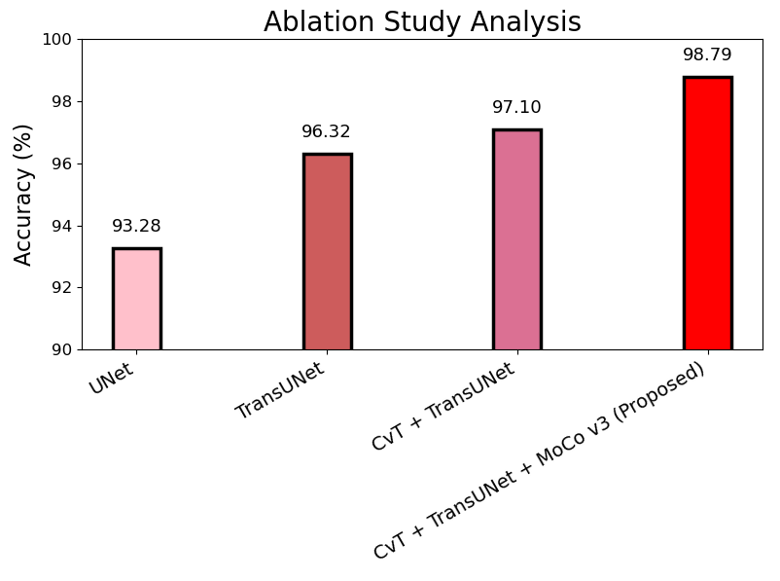

Figure 12 Ablation study Analysis

Table 5 and Figure 12 present the ablation study analysis, highlighting the progressive improvements in model performance. The baseline UNet achieved an accuracy of 93.28%, which was significantly enhanced to 96.32% with the introduction of TransUNet. Further integration of the Compact Vision Transformer (CvT) with TransUNet increased the accuracy to 97.10%. At last, the suggested model which combined CvT, TransUNet, and Momentum Contrastive Learning (MoCo v3) failed the lowest accuracy of 98.79%, thereby proving the value of each added element.

4.5 Limitation

Despite the promising performance of the lightweight CvT–TransUNet framework for chronic and polycystic kidney disease detection, certain limitations remain. The quality and diversity of the MRI dataset significantly influence the model’s presentation, potentially limiting its applicability to other imaging modalities or demographic groups. Additionally, while the integration of Momentum Contrastive Learning enhances feature representations, it may still demand substantial computational resources during the pretraining phase. Finally, although the framework is lightweight, it may face challenges in real-time deployment on resource-constrained medical devices without further optimization.

5. Conclusion

In conclusion, the proposed lightweight CvT–TransUNet framework, combined with Momentum Contrastive Learning (MoCo v3), offers a highly effective and effectual solution for the early detection of CKD and PKD from MRI images. The framework achieves excellent classification accuracy with greatly lowered computational cost by using CvT for robust global feature extraction and TransUNet for exact renal area segmentation. Integrating self-supervised learning with MoCo v3 helps to overcome one of the primary problems in medical imaging analysis by increasing the capacity of the model to create important representations from sparsely tagged medical data. Experimental data show that the proposed approach achieves higher accuracy, durability, and generalisation capacity than conventional deep learning approaches. Overall, this research highlights the potential of combining lightweight transformers with contrastive learning techniques to advance computer-aided diagnosis systems, offering a promising tool to assist clinicians in the timely and reliable identification of kidney diseases.

Reference
- Kovesdy, C. P. (2022). Epidemiology of chronic kidney disease: an update 2022. Kidney international supplements, 12(1), 7-11. https://doi.org/10.1016/j.kisu.2021.11.003
- Righini, M., Corsi, C., Sciascia, N., Aiello, V., Ciurli, F., Lerario, S., ... & Capelli, I. (2025). The need for clinical, genetic and radiological characterization of atypical polycystic kidney disease. Journal of Nephrology, 1-11. https://doi.org/10.1007/s40620-024-02181-6
- Provenzano, M., Borelli, G., Pirklbauer, M., & Mayer, G. (2024). Insights in clinical research in nephrology. Frontiers in Nephrology, 4, 1441190. https://doi.org/10.3389/fneph.2024.1441190
- Márquez-Nogueras, K. M., Vuchkovska, V., & Kuo, I. Y. (2023). Calcium signaling in polycystic kidney disease-cell death and survival. Cell calcium, 112, 102733. https://doi.org/10.1016/j.ceca.2023.102733
- Lao, X. Q., Bo, Y., Chen, D., Zhang, K., & Szeto, C. C. (2024). Environmental pollution to kidney disease: an updated review of current knowledge and future directions. Kidney international. https://doi.org/10.1016/j.kint.2024.04.021
- Tangri, N., Peach, E. J., Franzén, S., Barone, S., & Kushner, P. R. (2023). Patient management and clinical outcomes associated with a recorded diagnosis of stage 3 chronic kidney disease: the REVEAL-CKD study. Advances in Therapy, 40(6), 2869-2885. https://doi.org/10.1007/s12325-023-02482-5
- Bai, Y., Wei, C., Li, P., Sun, X., Cai, G., Chen, X., & Hong, Q. (2022). Primary cilium in kidney development, function and disease. Frontiers in endocrinology, 13, 952055. https://doi.org/10.3389/fendo.2022.952055
- Mondol, C., Shamrat, F. J. M., Hasan, M. R., Alam, S., Ghosh, P., Tasnim, Z., ... & Ibrahim, S. M. (2022). Early prediction of chronic kidney disease: A comprehensive performance analysis of deep learning models. Algorithms, 15(9), 308. https://doi.org/10.3390/a15090308
- Poonia, R. C., Gupta, M. K., Abunadi, I., Albraikan, A. A., Al-Wesabi, F. N., & Hamza, M. A. (2022, February). Intelligent diagnostic prediction and classification models for detection of kidney disease. In Healthcare (Vol. 10, No. 2, p. 371). MDPI. https://doi.org/10.3390/healthcare10020371
- Canbay, Y., Adsiz, S., & Canbay, P. (2024). Privacy-Preserving Transfer Learning Framework for Kidney Disease Detection. Applied Sciences, 14(19), 8629. https://doi.org/10.3390/app14198629
- Arif, M. S., Rehman, A. U., & Asif, D. (2024). Explainable Machine Learning Model for Chronic Kidney Disease Prediction. Algorithms, 17(10), 443. https://doi.org/10.3390/a17100443
- Dissanayake, D. V., Sobana, S., Yogarajah, B., & Nagulan, R. (2023, February). Chronic Kidney Disease Detection using Machine Learning Algorithms: A Sri Lankan Study. In 2023 3rd International Conference on Advanced Research in Computing (ICARC) (pp. 60-65). IEEE. https://doi.org/10.1109/ICARC57651.2023.10145656
- Saif, D., Sarhan, A. M., & Elshennawy, N. M. (2024). Early prediction of chronic kidney disease based on ensemble of deep learning models and optimizers. Journal of electrical systems and information technology, 11(1), 17. https://doi.org/10.1186/s43067-024-00142-4
- Dharmarathne, G., Bogahawaththa, M., McAfee, M., Rathnayake, U., & Meddage, D. P. P. (2024). On the diagnosis of chronic kidney disease using a machine learning-based interface with explainable artificial intelligence. Intelligent Systems with Applications, 22, 200397. https://doi.org/10.1016/j.iswa.2024.200397
- https://www.kaggle.com/datasets/stanfordcompute/code-images
- Altini, N., Prencipe, B., Cascarano, G. D., Brunetti, A., Brunetti, G., Triggiani, V., ... & Bevilacqua, V. (2022). Liver, kidney and spleen segmentation from CT scans and MRI with deep learning: A survey. Neurocomputing, 490, 30-53. https://doi.org/10.1016/j.neucom.2021.08.157
- Chen, J., Mei, J., Li, X., Lu, Y., Yu, Q., Wei, Q., ... & Zhou, Y. (2024). TransUNet: Rethinking the U-Net architecture design for medical image segmentation through the lens of transformers. Medical Image Analysis, 97, 103280. https://doi.org/10.1016/j.media.2024.103280
- Zhang, T., Xu, W., Luo, B., & Wang, G. (2025). Depth-wise convolutions in vision transformers for efficient training on small datasets. Neurocomputing, 617, 128998. https://doi.org/10.1016/j.neucom.2024.128998
- Paul, S., Patterson, Z., & Bouguila, N. (2023, June). Crossmoco: multi-modal momentum contrastive learning for point cloud. In 2023 20th Conference on Robots and Vision (CRV) (pp. 273-280). IEEE. https://doi.org/10.1109/CRV60082.2023.00042
- Swain, D., Mehta, U., Bhatt, A., Patel, H., Patel, K., Mehta, D., ... & Manika, S. (2023). A robust chronic kidney disease classifier using machine learning. Electronics, 12(1), 212. https://doi.org/10.3390/electronics12010212
- Ullah, Z., & Jamjoom, M. (2023). [Retracted] Early Detection and Diagnosis of Chronic Kidney Disease Based on Selected Predominant Features. Journal of healthcare engineering, 2023(1), 3553216. https://doi.org/10.1155/2023/3553216
- Krishnamurthy, S., Ks, K., Dovgan, E., Luštrek, M., Gradišek Piletič, B., Srinivasan, K., ... & Syed-Abdul, S. (2021, May). Machine learning prediction models for chronic kidney disease using national health insurance claim data in Taiwan. In Healthcare (Vol. 9, No. 5, p. 546). MDPI. https://doi.org/10.3390/healthcare9050546
- Singh, V., Asari, V. K., & Rajasekaran, R. (2022). A deep neural network for early detection and prediction of chronic kidney disease. Diagnostics, 12(1), 116. https://doi.org/10.3390/diagnostics12010116



Mrs. V. Shanmugapriya graduated B.Tech Information Technology at Syed Ammal Engineering College, from Anna University in the year of 2012, Post graduated in M.E. Computer Science and Engineering from Mohamed Sathak Engineering College, from Anna University in the year 2014. Having 3 years of Engineering teaching experience, She is now presently working as Assistant Professor in Department of Information Technology at Jeppiaar Institute of Technology, Kunnam, Sriperumbudur, India. Areas of Interests are Data Structure and Machine Learning.



Dr. R. Annamalai currently serves as an Associate Professor, in the Department of Computer Science and Engineering, Amrita School of Engineering, Amrita Vishwa Vidyapeetham, Chennai. He has 20 years of experience in teaching and industry. His areas of interest include Machine Learning Programming languages, optimization algorithms. Dr. R. Annamalai is currently guiding 7 PhD research scholars and has guided 10 M.E projects and is Doctoral Committee Member for 2 Ph.D. Research Scholars. He has delivered many guest Lectures and acted as resource person in Faculty development programs. He has also acted as program committee member and session chair in national and international conferences.

